BitKeeper—Before Git

Author of Git = author of Linux landorf

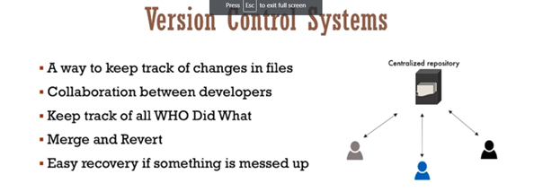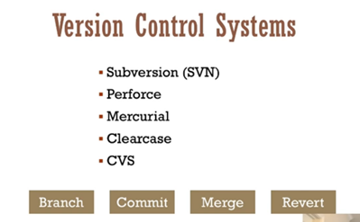

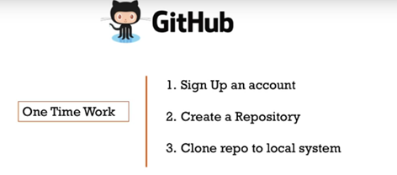

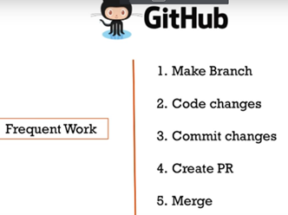

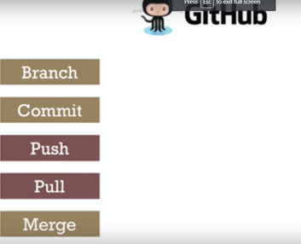

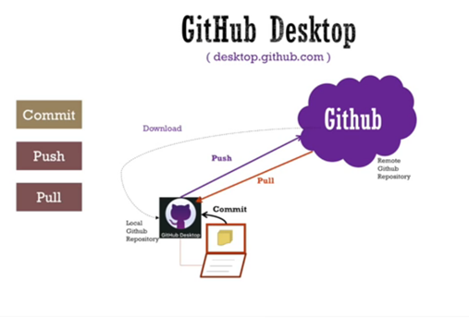

HOW TO CREATE PROJECT USING COMMAND IN GITHUB

1. Add the code in Remote Repository ion Master Branch
2. To list all the branches name-🡪 **git branch**
3. Create a new branch—**git branch MyNewBranch**
4. To start working on the branch, first need to checkout means switch from Master branch to newbranch- **git checkout MyNewBranch**
5. Do some changes like ---

* Create New file ---**touch NEwFile.txt**
* Add New file in NewBranch🡪 **git add . or git add -all**
* **git commit –m “New file added”**

**or to add and commit the files in one go :-> git commit -a -m** "Do something once more**"**

* **git push –u origin MyNewBranch**

1. Now, Merge the code of NewBranch Code into Master branch

* First need to switch(checkout) to master branch-> **git checkout master**

After this command on local machine, it also switch to branches , means files dipslyed in newbanch will not be visisble, because we switched to master branch and this branch having no new files.

* Merge the code into master –> **git merge MyNewBranch**
* Push the code into master branch-> **git push –u origin master**

1. To Delete the NewBranch from Local Repository not from Remote Repo. (make sure you have checkedout from that branch which you want to dlete)🡪 **git branch –d MyNewBranch**
2. To delete the NewBranch FromRemote Branch-> **git push origin –delete MyNewBranch**
3. To copy the whole code from remote Repository to My System->

**git clone** [**https://github.com/Mshaveta/BranchMerge.git**](https://github.com/Mshaveta/BranchMerge.git)

1. If any person make changes in file and have to snd to remote repo then

* Add files in local repo.
* Commit the code
* Push the code to master branch using command: **git push**

1. To get the changes (which are done by other developers) on local System we need to use the command:

**git pull**

1. To remove files from the staging area, use the following command

**git rm --cached my-file.ts**

1. **To see the list of all files: ls**
2. **TO check the log -🡪 git log**

**Difference Between clone and pull command:**

If you clone a remote repository, Git will:

1. Download the entire project into a specified directory; and
2. Create a remote repository called origin and point it to the URL you pass.
3. The last item simply means that you don't need to run "git remote add origin git@github.com:YourUsername/your-app.git" after cloning a repository. The "clone" command will add a remote origin automatically, and you can simply run "git push" from the repository.

When you run the "pull" command, Git will:

1. Pull changes in the current branch made by other developers; and
2. Synchronize your local repository with the remote repository.
3. The "pull" command doesn't create a new directory with the project name. Git will only pull updates to make sure that your the local repository is up to date.

If this type of Error Occur:

Step 1 : Download git, use `git config` to tell git about my username & email. Worked fine.

All the following command were executed in my new local repo's main directory

Step 2 : `git init`. Worked fine.

Step 3 : Do a `git add` on all my files. Worked fine.

Step 4 : Do the first commit : `git commit -m "First commit from new computer"`. Worked fine.

Step 5 : Do `git remote add origin <https://github.com/roparzhhemon/myremoterepo.git>`. Worked fine, according to  
`git remote -v`.

Step 6 : `git push`. Got the following error message :

fatal: The current branch master has no upstream branch.

To push the current branch and set the remote as upstream, use

git push --set-upstream origin master

Step 7 : Do as I'm told, and type : `git push --set-upstream origin master`. Got the following error message :

error: failed to push some refs to [remote repo]

hint: Updates were rejected because the remote contains work that you do

hint: not have locally. This is usually caused by another repository pushing

hint: to the same ref. You may want to first integrate the remote changes

hint: (e.g., 'git pull ...') before pushing again.

hint: See the 'Note about fast-forwards' in 'git push --help' for details.

Step 8 : Do as I'm told, and type : `git pull`. Got the following message :

warning: no common commits

remote: Counting objects: 11450, done.

remote: Compressing objects: 100% (17/17), done.

remote: Total 11450 (delta 13), reused 17 (delta 8), pack-reused 11425

Receiving objects: 100% (11450/11450), 1.96 MiB | 2.65 MiB/s, done.

Resolving deltas: 100% (7710/7710), done.

From [remote repo]

* [new branch] master -> origin/master

There is no tracking information for the current branch.

Please specify which branch you want to merge with.

See git-pull(1) for details.

git pull <remote> <branch>

If you wish to set tracking information for this branch you can do so with:

git branch --set-upstream-to=origin/<branch> master

Step 9 : Do as I'm told, and type : `git branch --set-upstream-to=origin/master master`. Seemed to work, output the following :

Branch 'master' set up to track remote branch 'master' from 'origin'.

Step 10 : Try `git pull` again. Got the error message :

fatal: refusing to merge unrelated histories

Step 11 : Try `git push` again. Got the error message :

To [remote repo]

! [rejected] master -> master (non-fast-forward)

error: failed to push some refs to [remote repo]

hint: Updates were rejected because the tip of your current branch is behind

hint: its remote counterpart. Integrate the remote changes (e.g.

hint: 'git pull ...') before pushing again.

hint: See the 'Note about fast-forwards' in 'git push --help' for details.

To resolve such kind of error use command:

**git pull --allow-unrelated-histories**

**if following Error occurs:**

error: failed to push some refs to 'https://github.com/Mshaveta/test11.git

that mean , we have not commited the code.use command to commit the code

git commit –m “message”